2.1 (*Convert Celsius to Fahrenheit*) Write a program that reads a Celsius degree in

a **double** value from the console, then converts it to Fahrenheit and displays the

result. The formula for the conversion is as follows:

fahrenheit = (9 / 5) * celsius + 32

*Hint*: In Java, **9 / 5** is **1**, but **9.0 / 5** is **1.8**.

Here is a sample run:

Ans

import java.util.Scanner;  
  
public class celsiusFaherenheit{  
 public static void main(String[] args) {  
 Scanner sc = new Scanner(System.*in*);  
 System.*out*.println("Enter the value of celcius");  
 double celcius= sc.nextDouble();  
 double Faherenheit= (9.0/5)*(celcius+32);  
 System.*out*.println(celcius+"celcius is"+Faherenheit+ " fahrenheit");  
 }  
}

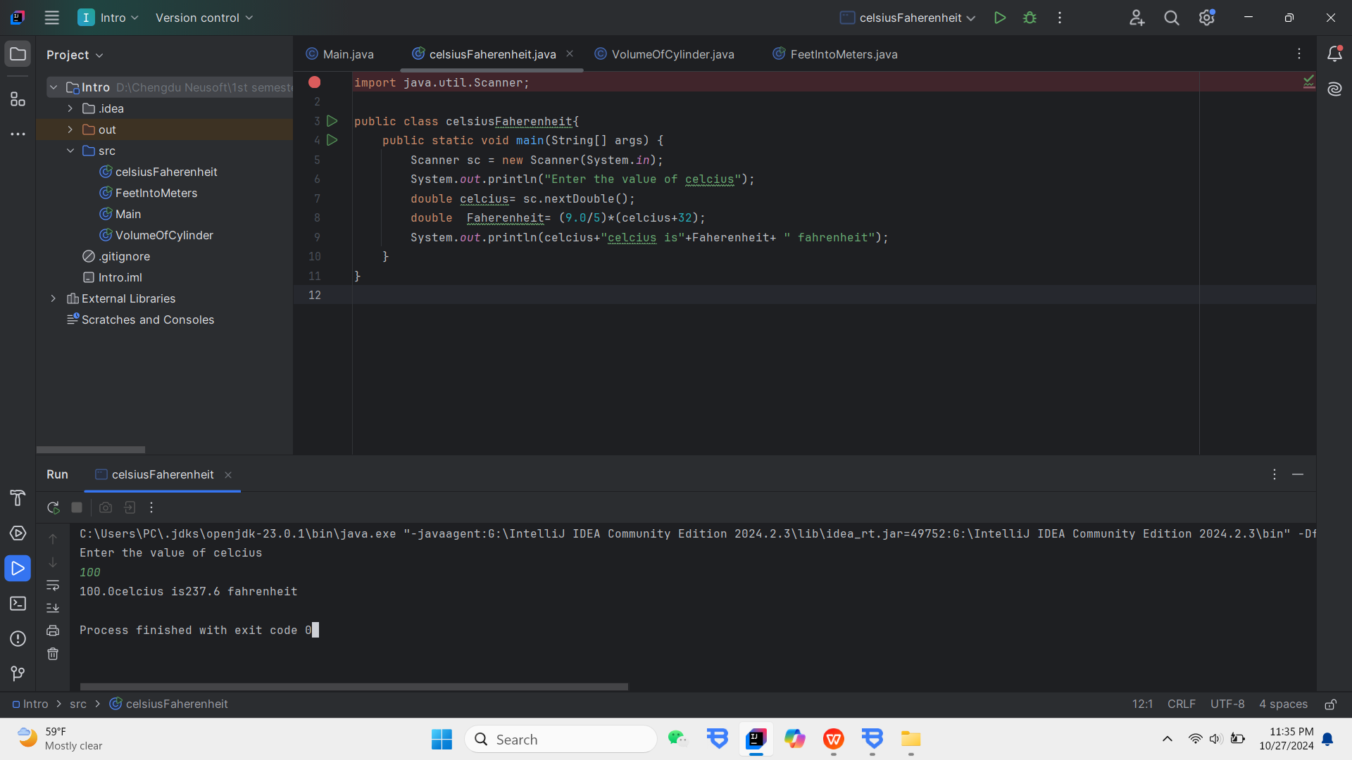

2.2(*Compute the volume of a cylinder*) Write a program that reads in the radius

and length of a cylinder and computes the area and volume using the following

formulas:

ans

import java.util.Scanner;  
  
public class VolumeOfCylinder {  
 public static void main(String[] args) {  
 Scanner sc= new Scanner(System.*in*);  
 final double PI= 3.1415;  
  
 System.*out*.println("Enter the value radius");  
 double redius=sc.nextDouble();  
 System.*out*.println("Enter the value length");  
 double length=sc.nextDouble();  
 //Now the volume cylinder  
 double area=redius* redius*PI;  
 double volume=area*length;  
 //Display Results  
 System.*out*.println("The area is "+area);  
 System.*out*.println("The volume is "+ volume);  
  
 }  
}

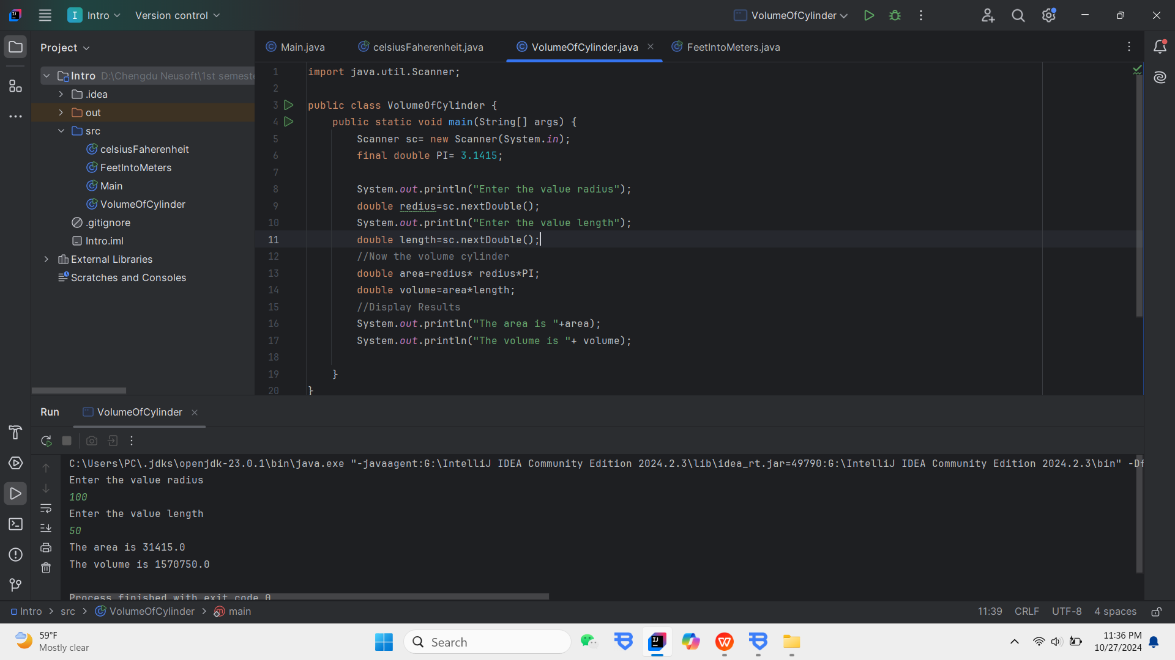

2.3 (*Convert feet into meters*) Write a program that reads a number in feet, converts it

to meters, and displays the result. One foot is **0.305** meter. Here is a sample run:

Ans

import java.util.Scanner;  
  
public class FeetIntoMeters {  
 public static void main(String[] args) {  
 Scanner scanner = new Scanner(System.*in*);  
System.*out*.println("Enter a value for feet;");  
double feet= scanner.nextDouble();  
 double meters= feet*0.305;  
//Display results  
 System.*out*.println(feet+"feet is");  
 System.*out*.println(meters+"meters");  
  
  
  
 }  
}

